**26/10/2021 CD LAB 7 2019103573**

**1.To convert an if statement multiple conditions to nested-if statements using pattern-action rules.**

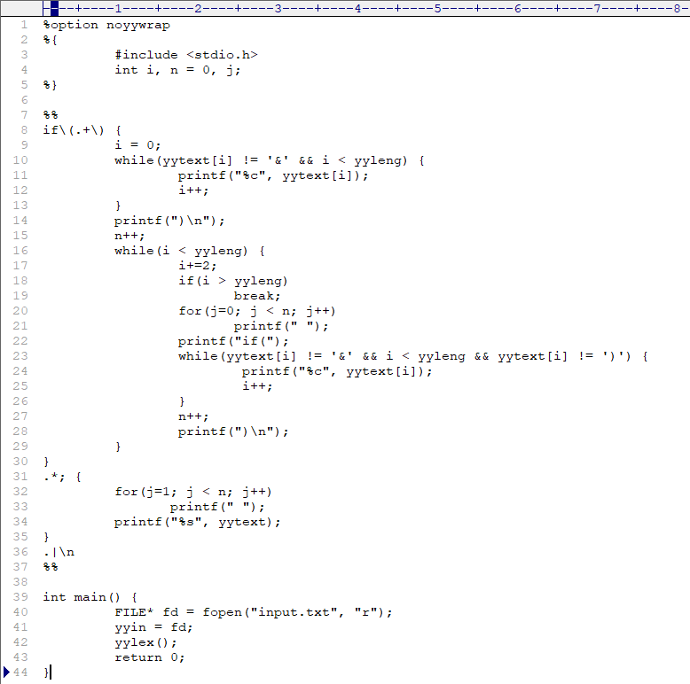**CODE :-**

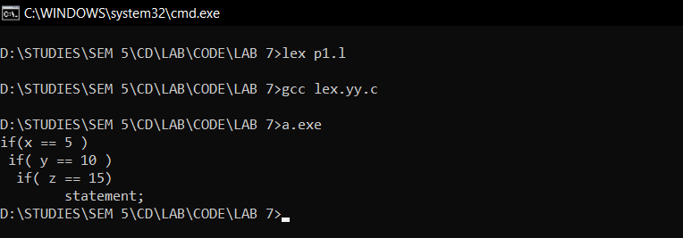**OUTPUT :-**

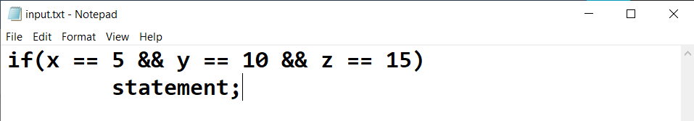

**2.Convert nested if-else to nested do - while syntax using LEX.**

**CODE :-**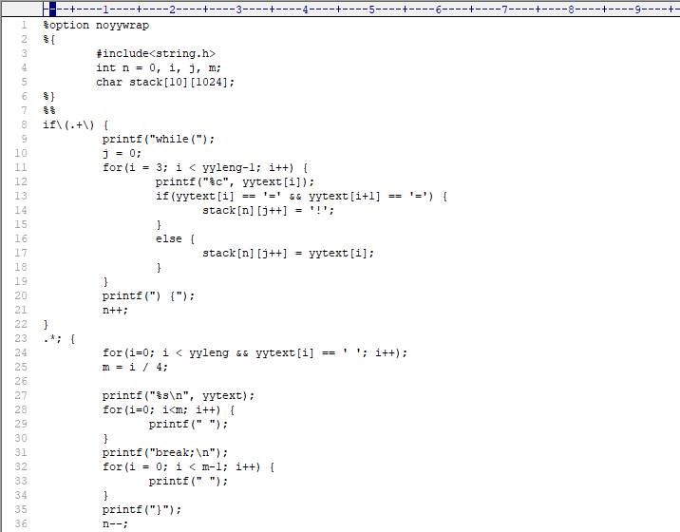

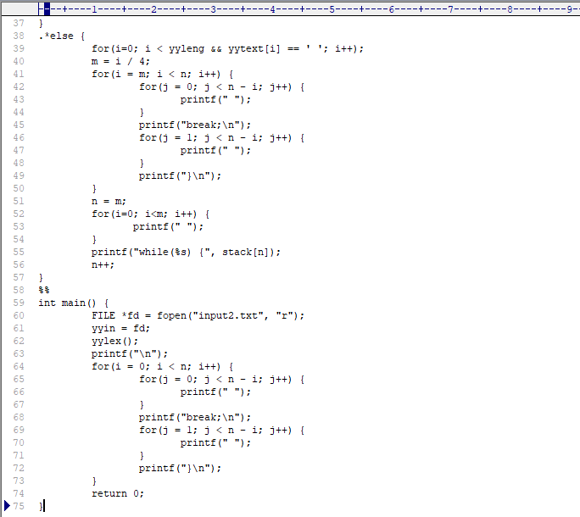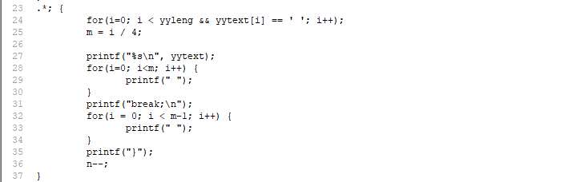

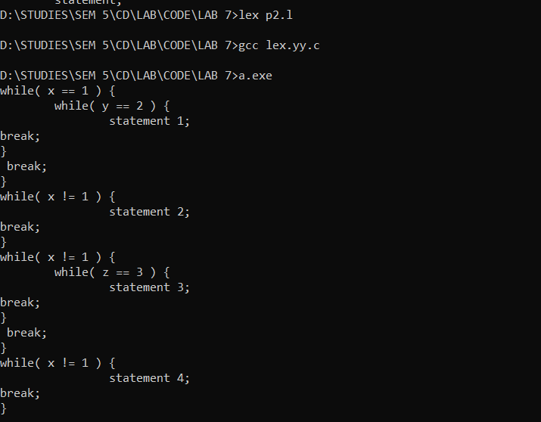**OUTPUT :-**

**3.Convert a nested if –else if consisting of multiple expressions into a single if-else if**

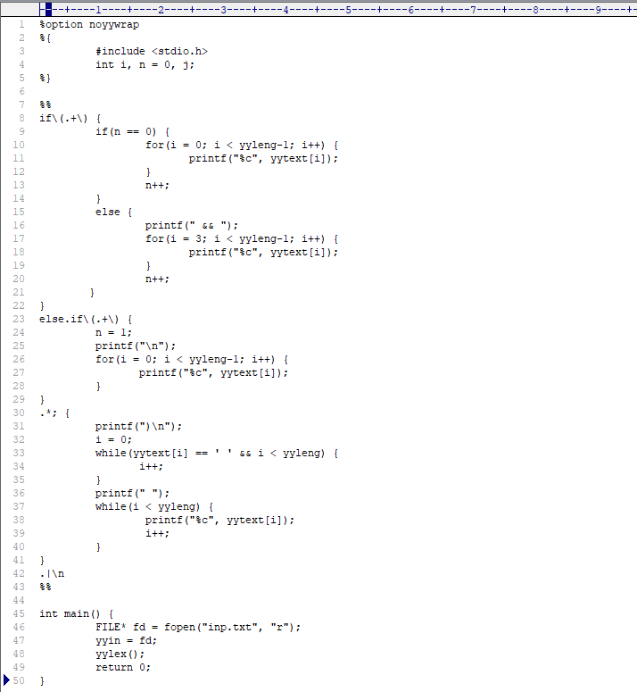**CODE :-**

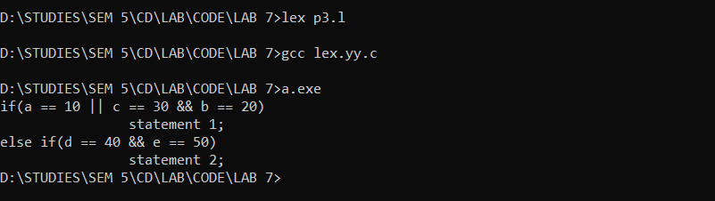**OUTPUT :-**

